1. 
2. Agenda:
   1. We will learn a bit more about consumer, consumer group and how they read data from a topic and partition.
3. It will help us to understand how many partitions to create in a topic and how many instances of a MS can be created when you scaling that app.
4. 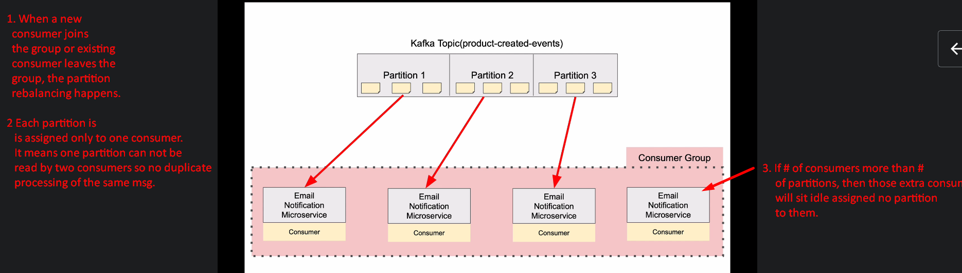
5. 